Adnan Jelani BUIC

CSL 114 Introduction to Information & Communication Technology Lab
Lab 10 Journal
HTML + CSS

Table of Contents
Lab Deliverables (submission guideline) 1
Lab Task 2
Task 1: Create a Basic HTML Form 2
Task 2: Create a Basic HTML Page and add external CSS 2
Task 3: Use Inline CSS 2
Task 4: Create a Simple Navbar with styling 2
Task 5: Create a Styled Box Using Div 2
Task 6: Create Two Side-by-Side Divs 2
Task 7: Background Color & Text Styling 2
Task 8: Final Task 2
Assessment Questions 3

Lab Deliverables (submission guideline)

Create a folder named after your enrollment number and add the following files:
  - The YourRollNumber_Lab10_CSS folder containing:
- Form.html (Task 1)
- Test.html (Task 2-7)
- My Profile.html (Complete Task 9)
  - A Word document (Download from Assignments and rename it to your enrollment number) containing a Full-Screen screenshot of the code and browser output after every task.

Zip the Folder and upload to LMS.

Lab Task

Task 1: Create a Basic HTML Form

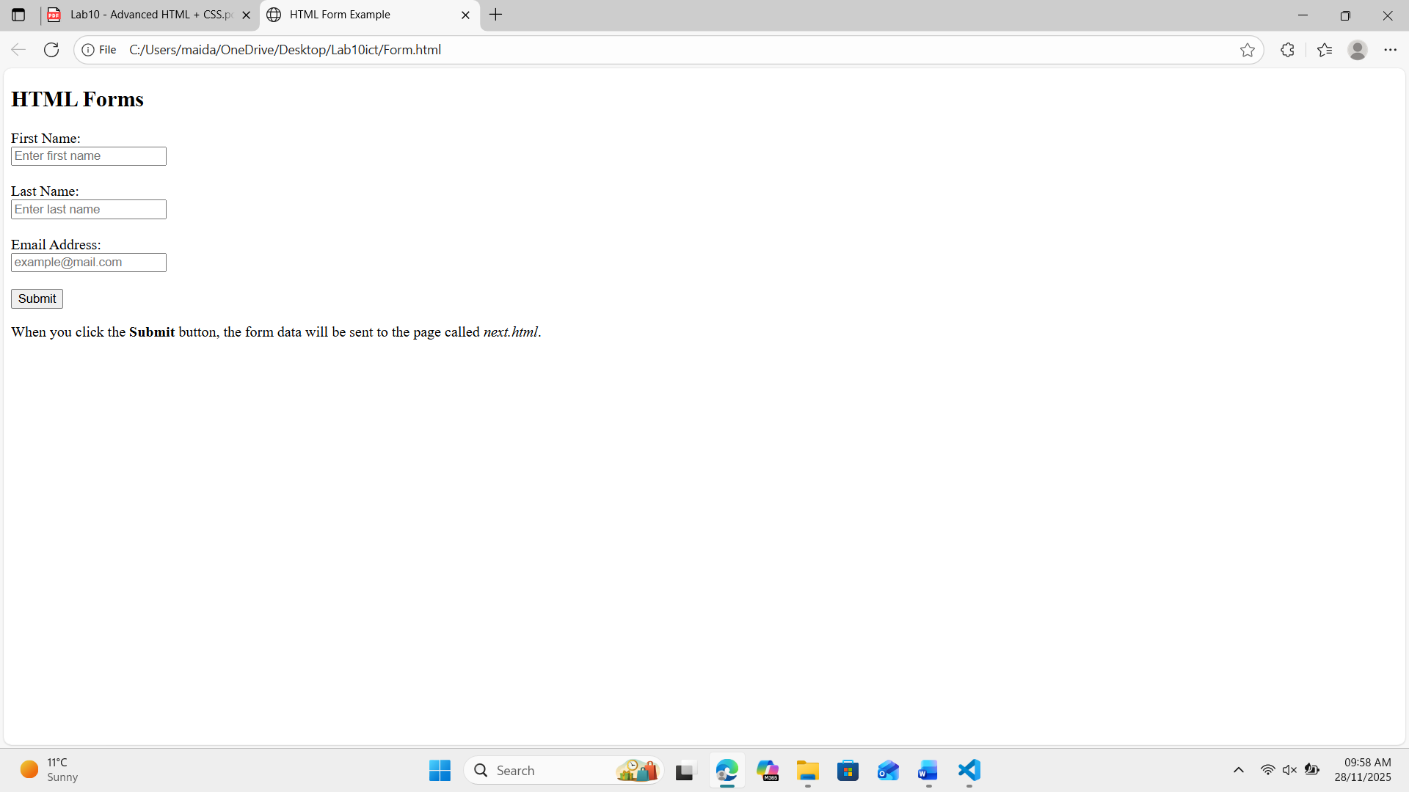

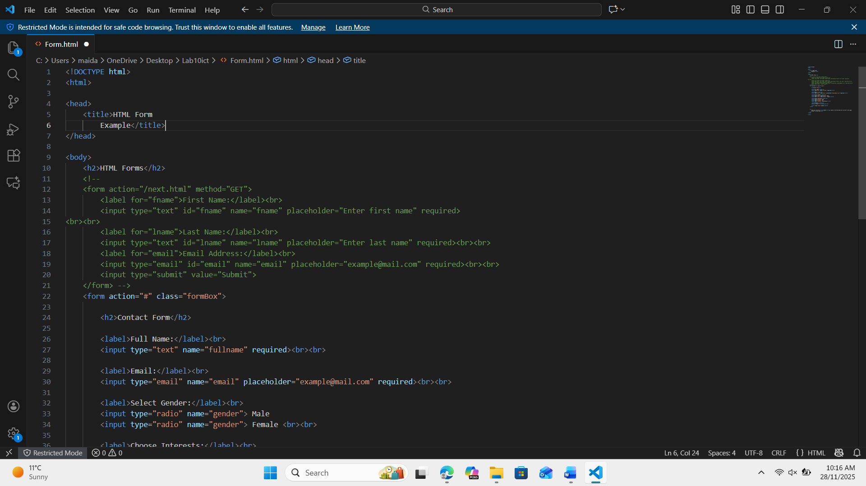

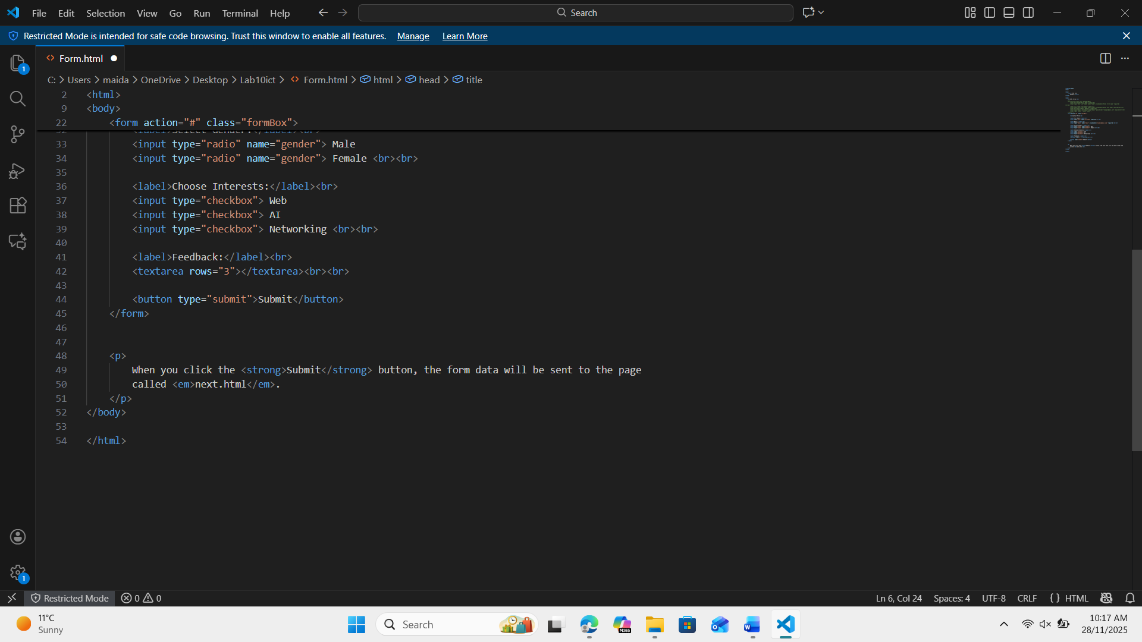

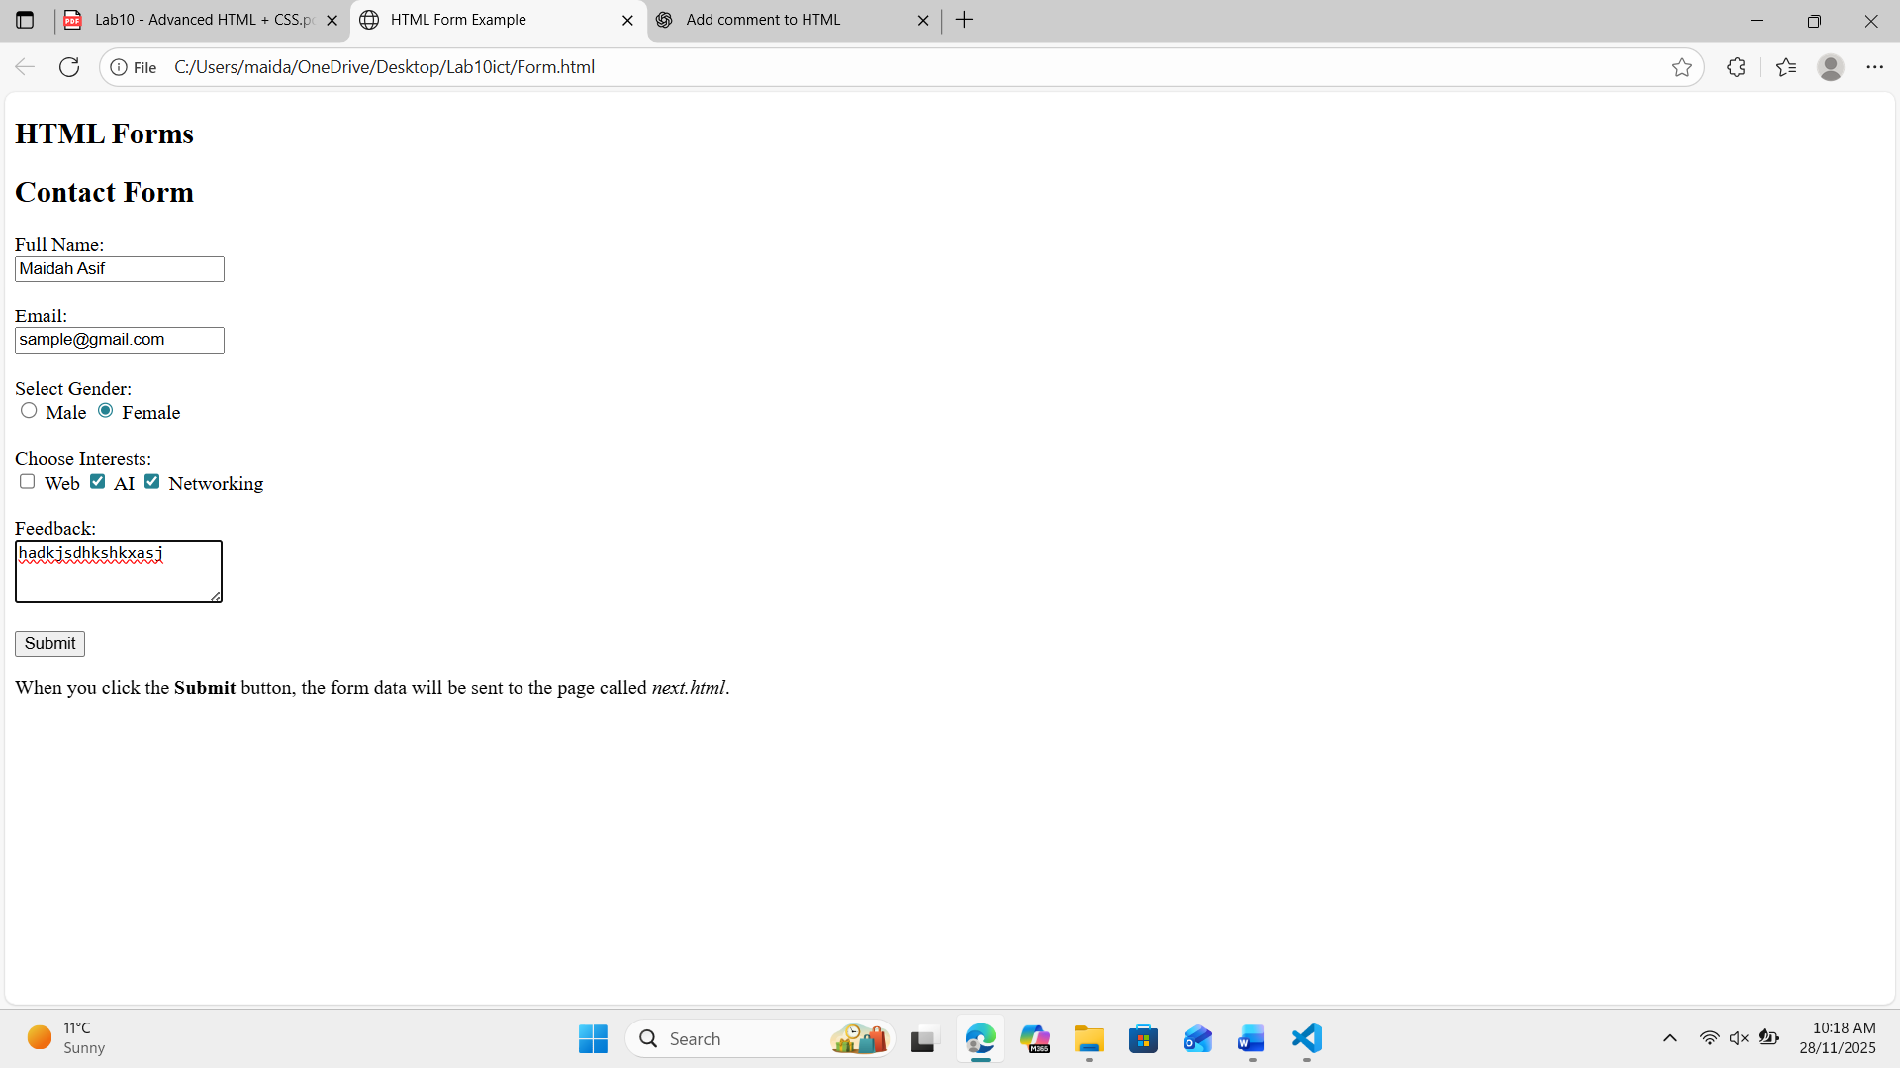

Task 2: Create a Basic HTML Page and add external CSS

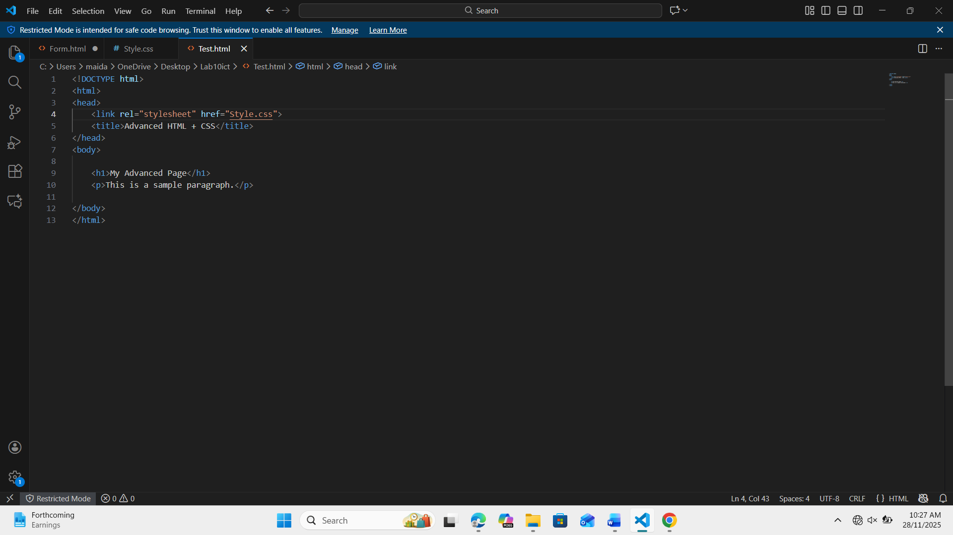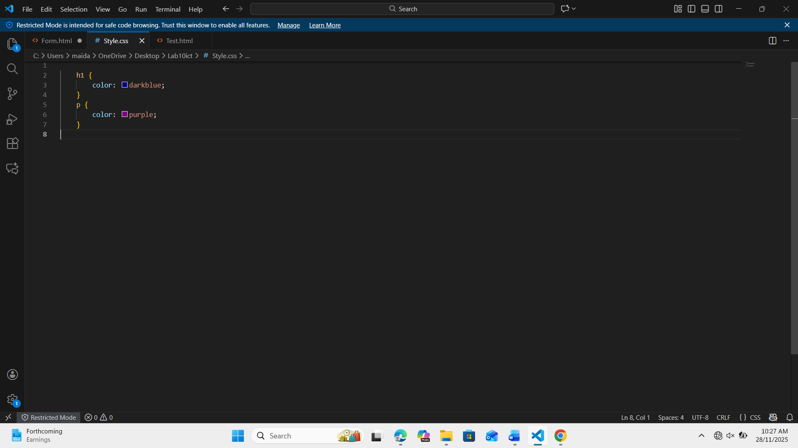
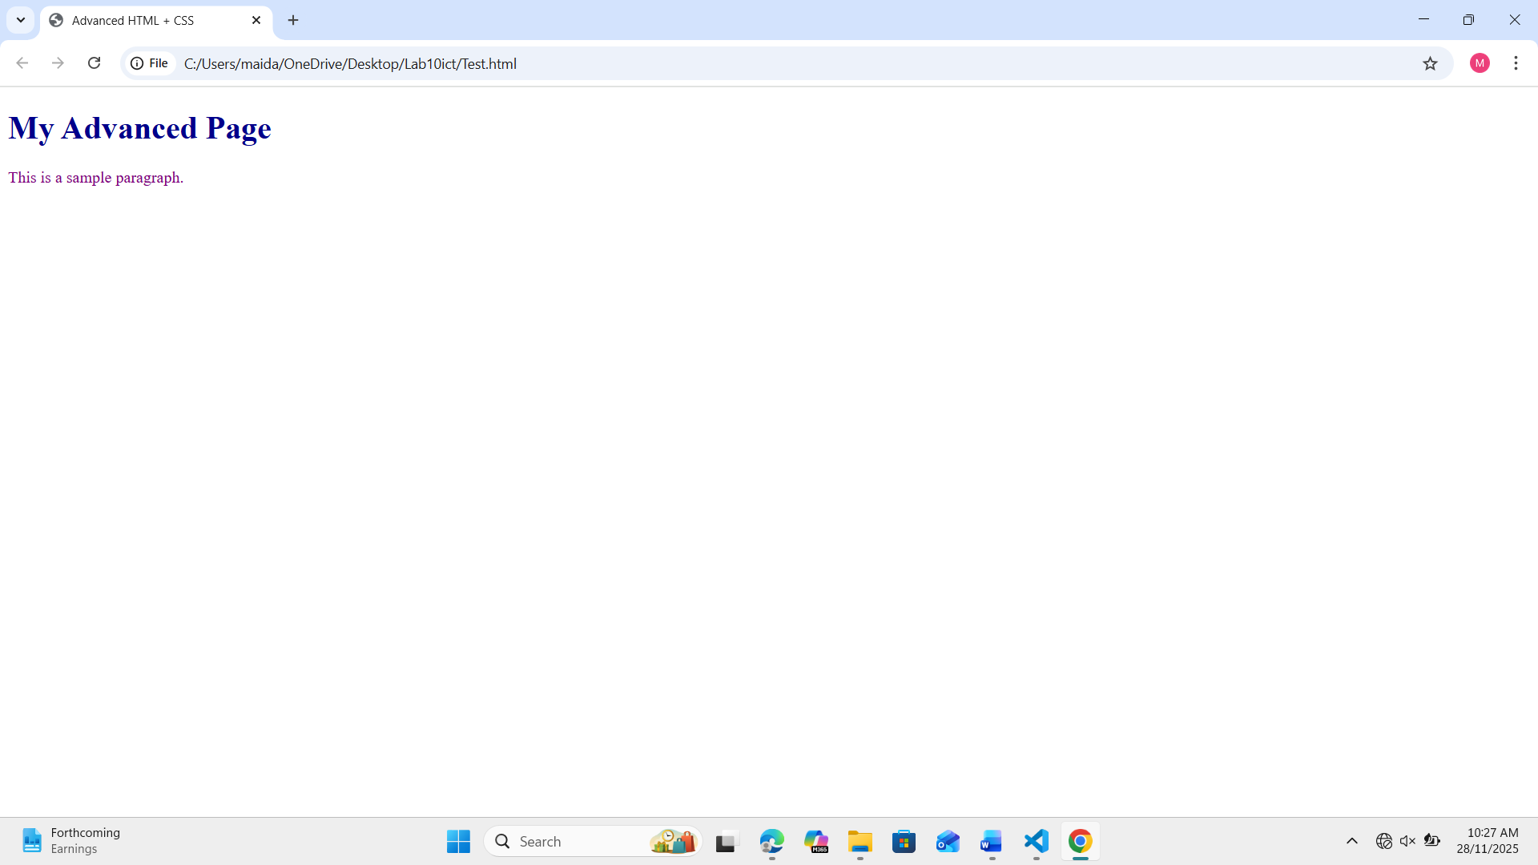

Task 3: Use Inline CSS

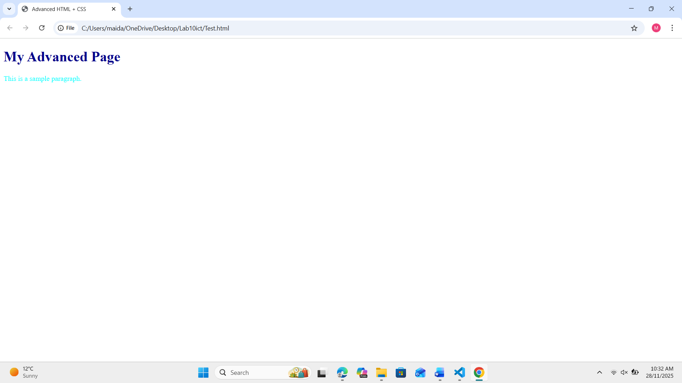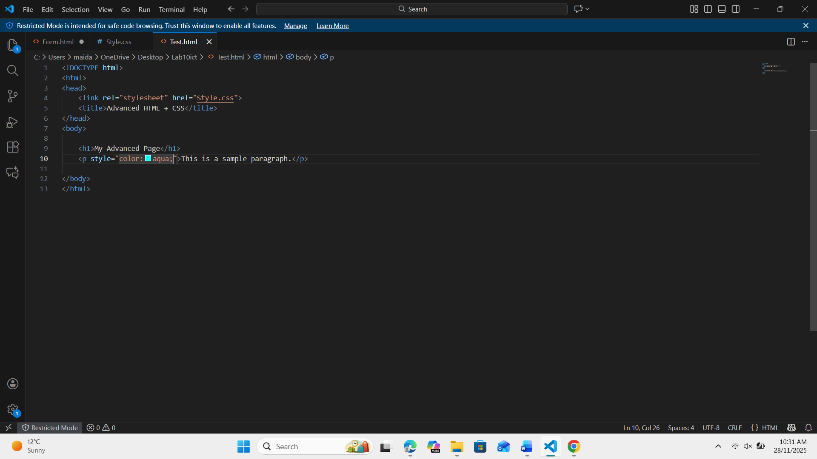

Task 4: Create a Simple Navbar with styling

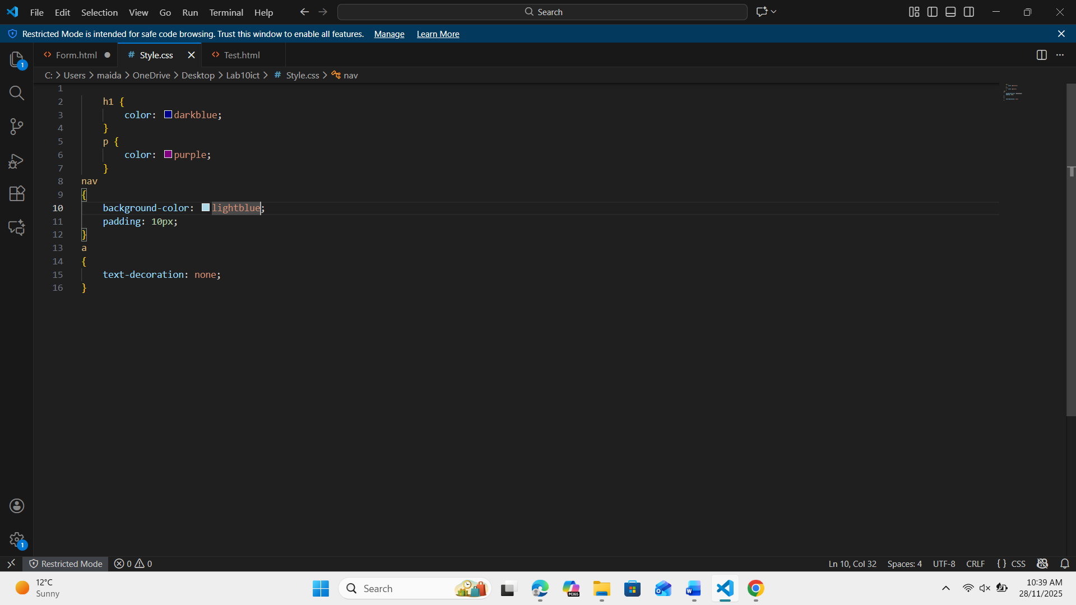

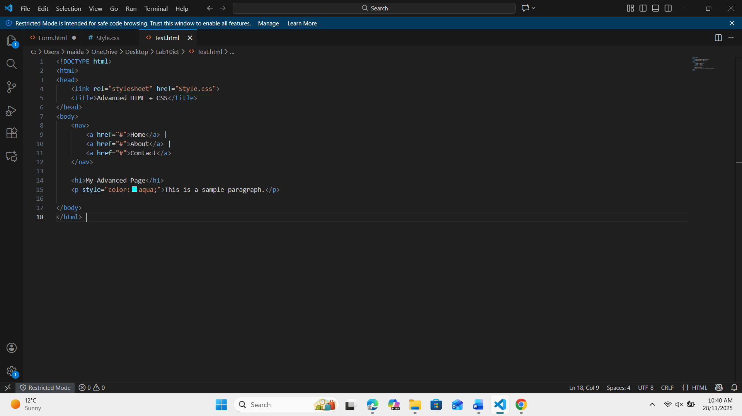

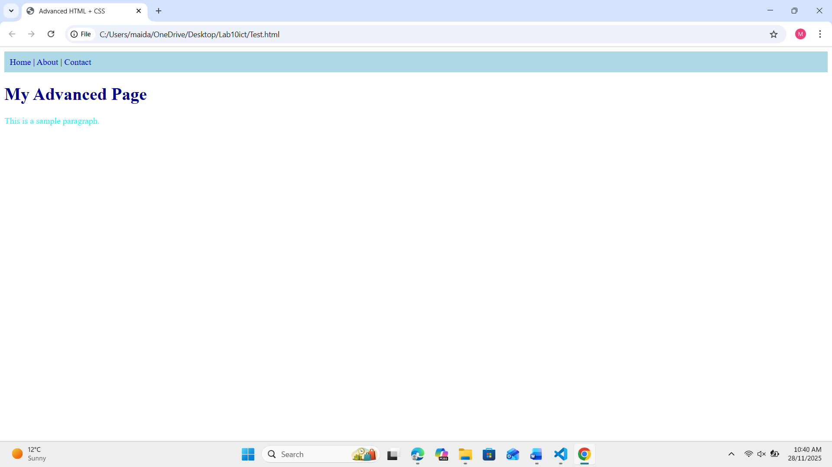

Task 5: Create a Styled Box Using Div

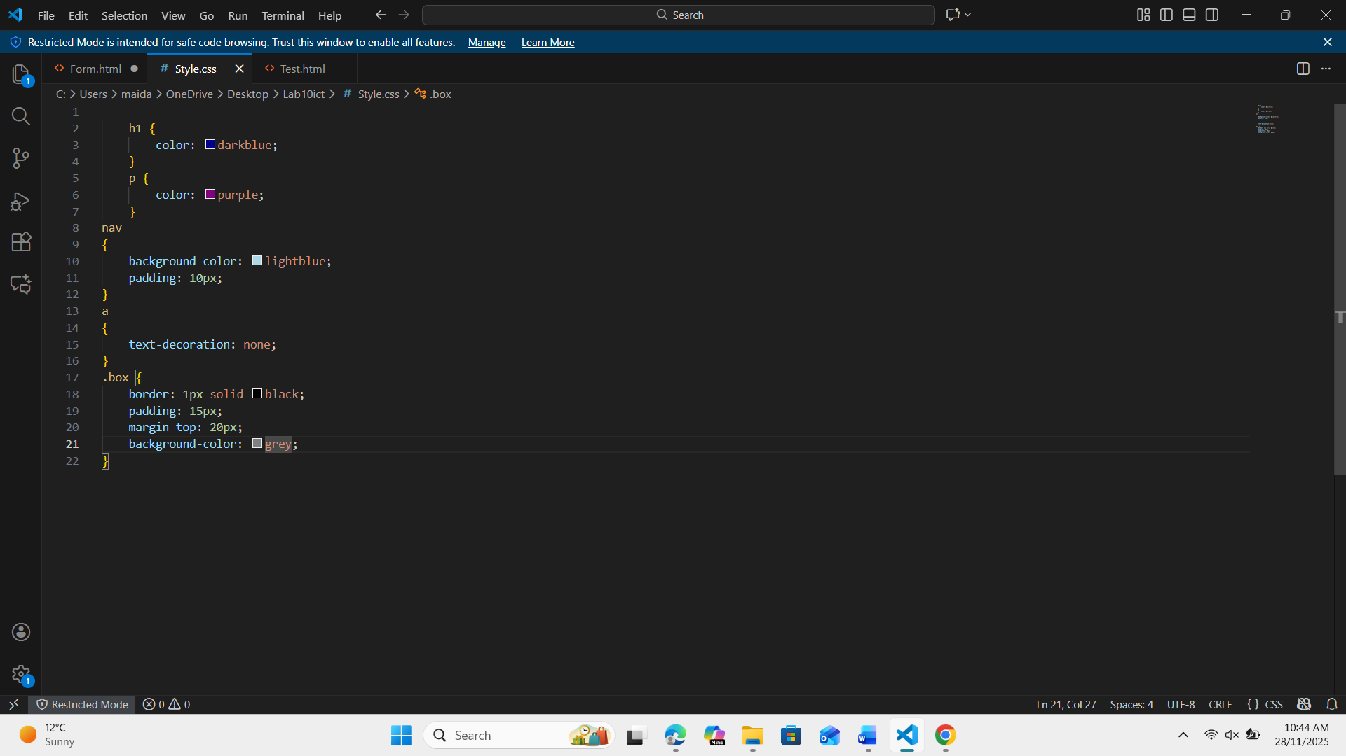

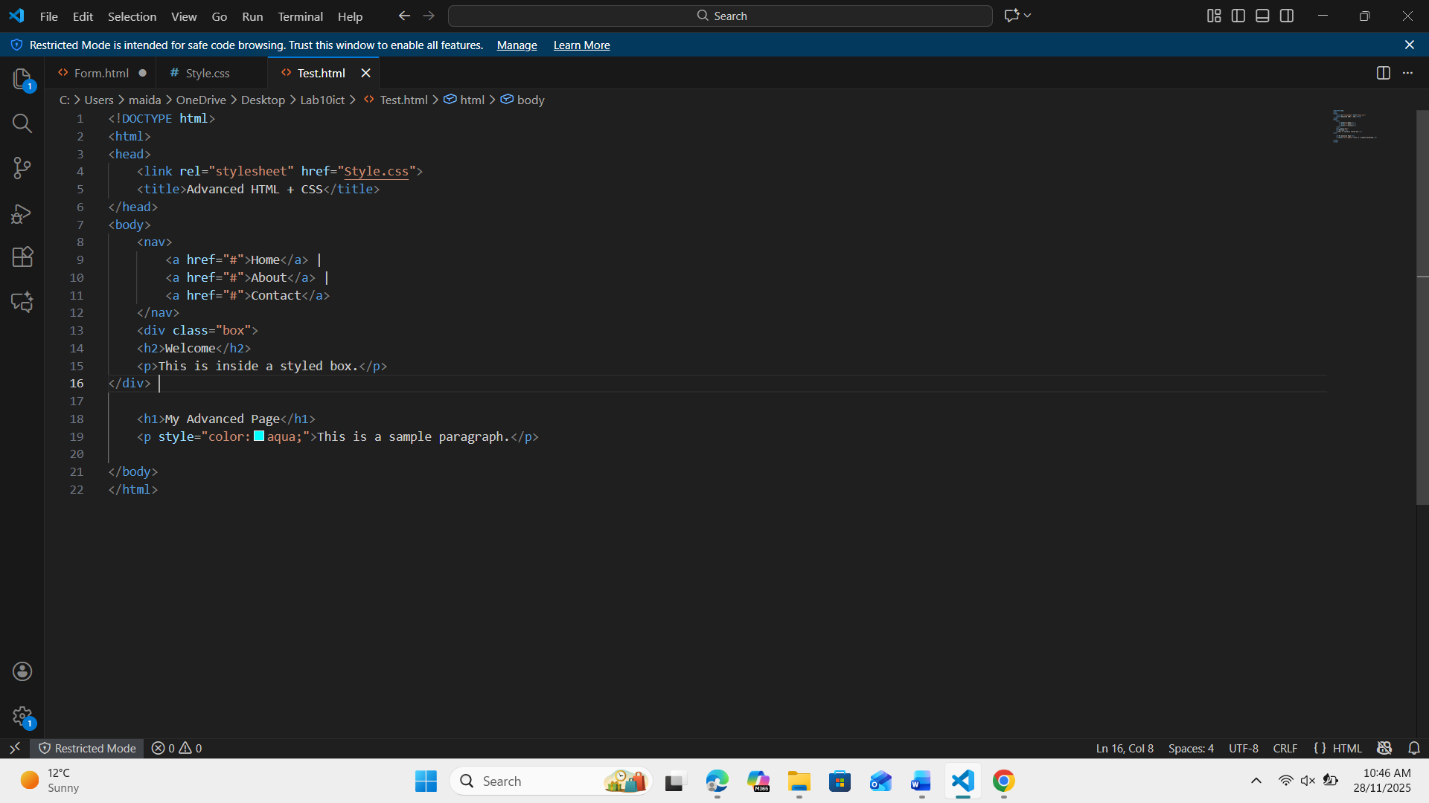

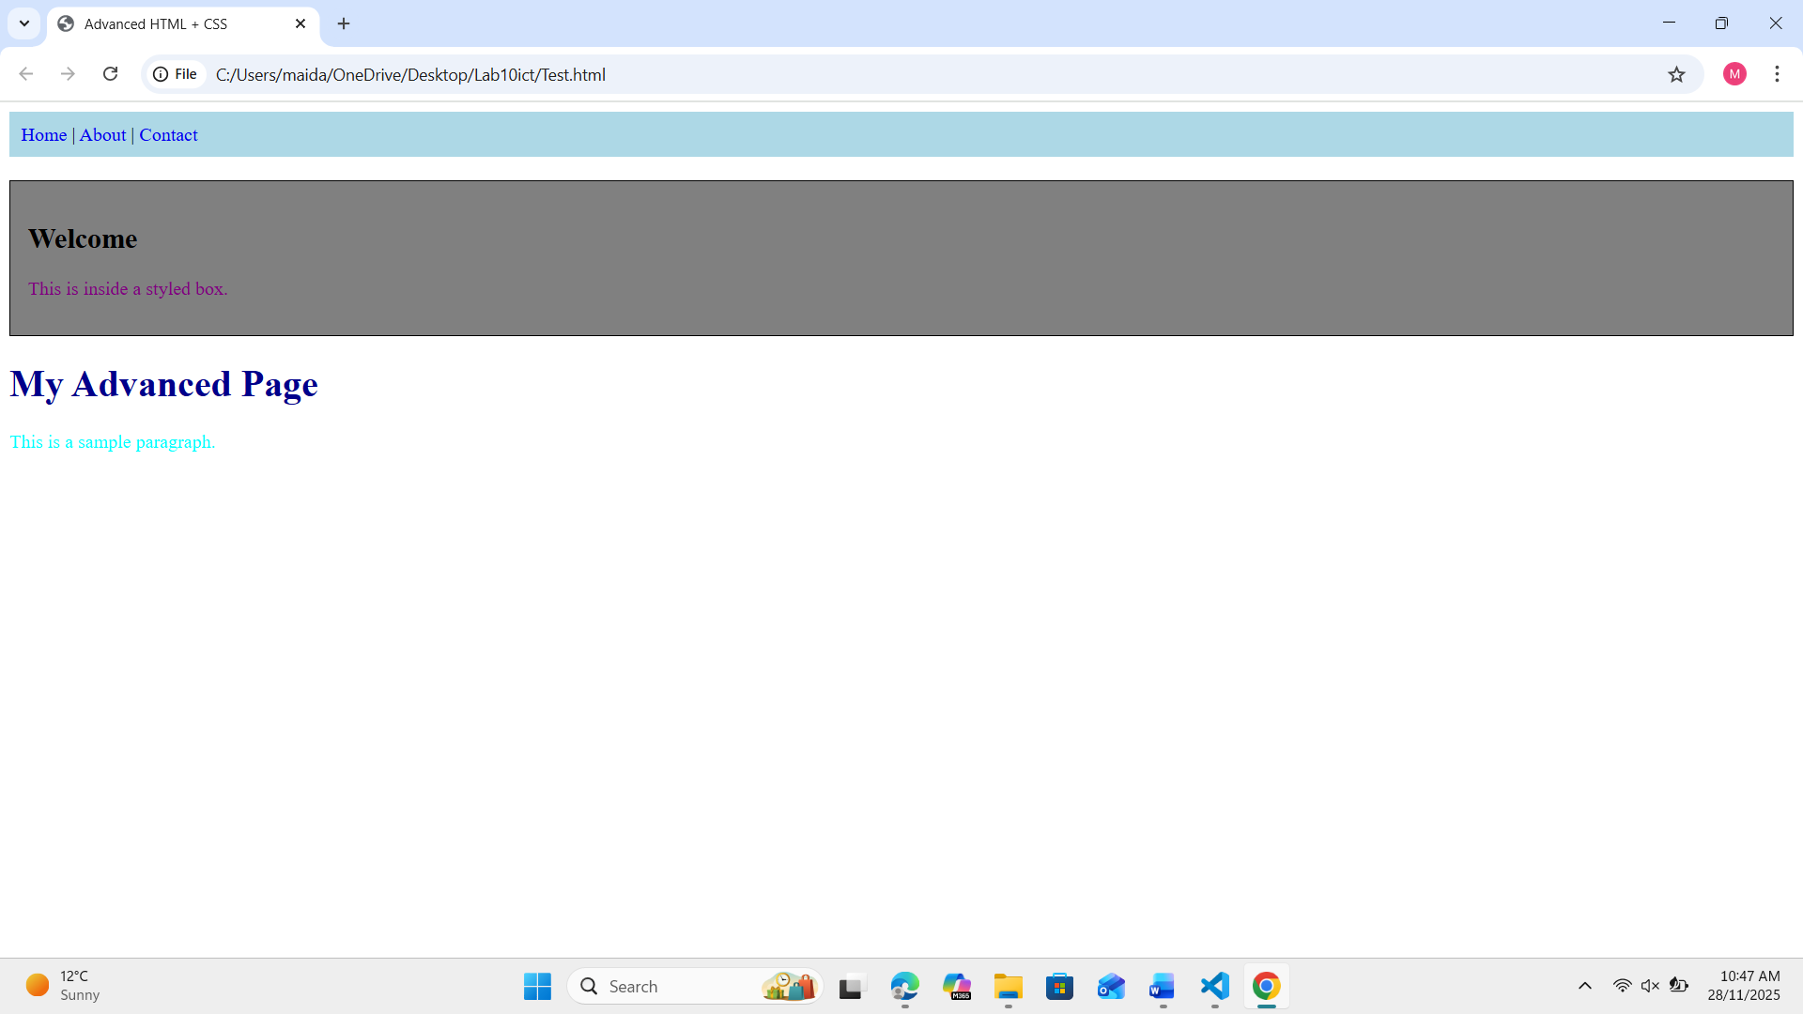

Task 6: Create Two Side-by-Side Divs
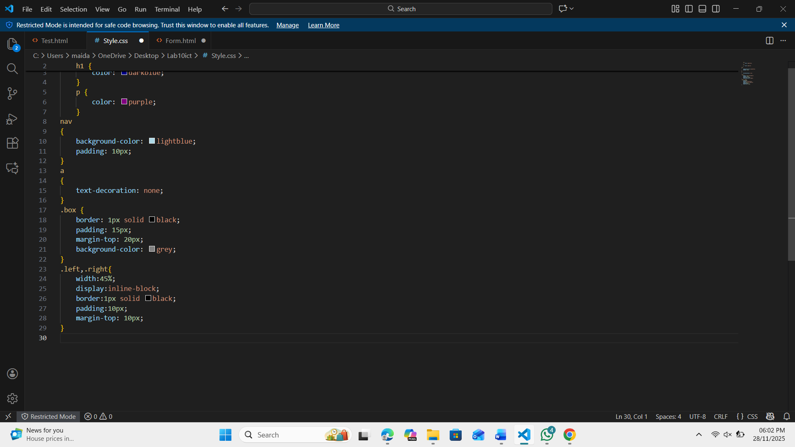
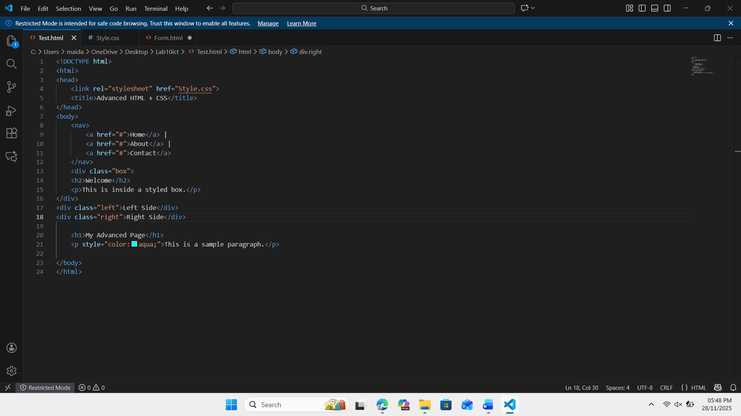
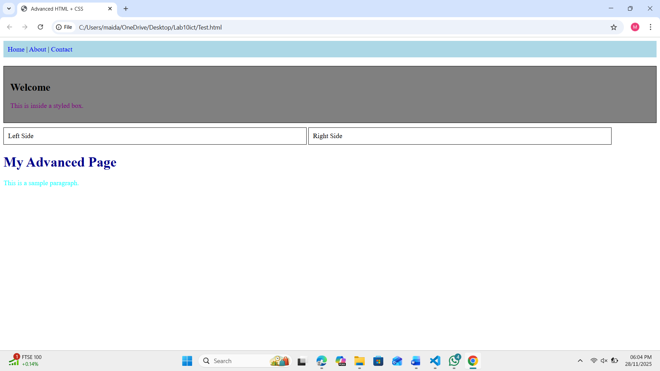

Task 7: Background Color & Text Styling
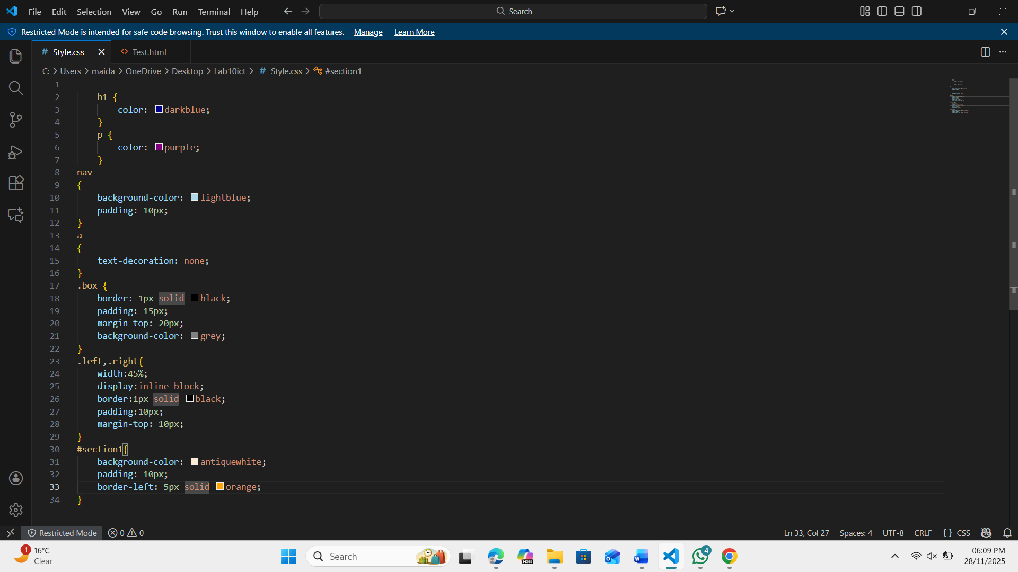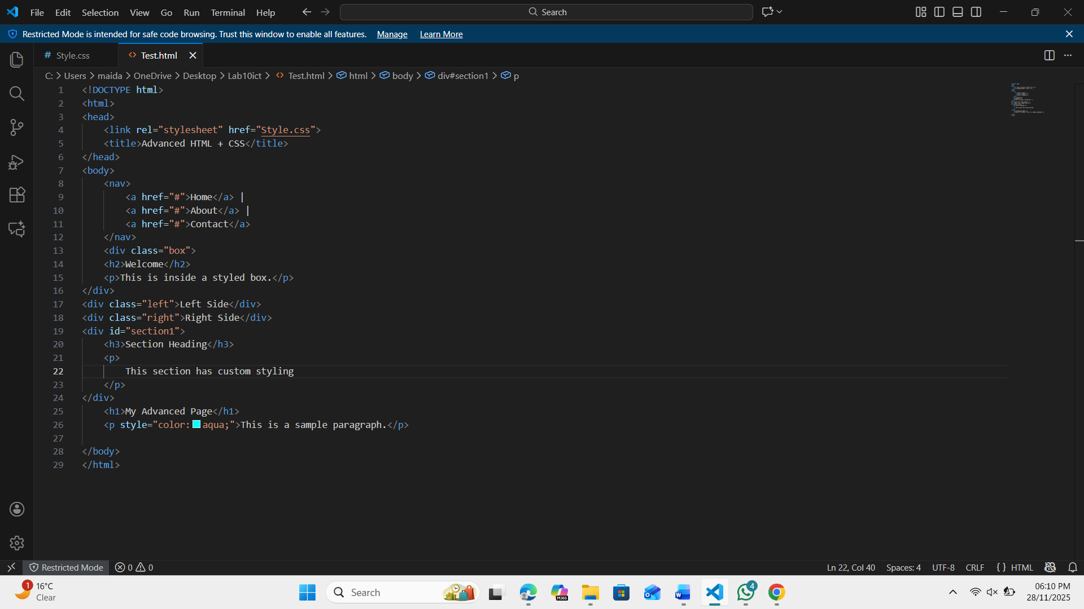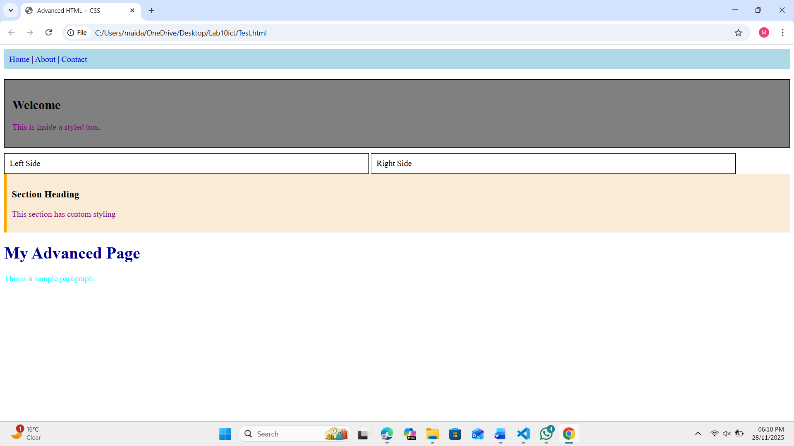

Task 8: Final Task

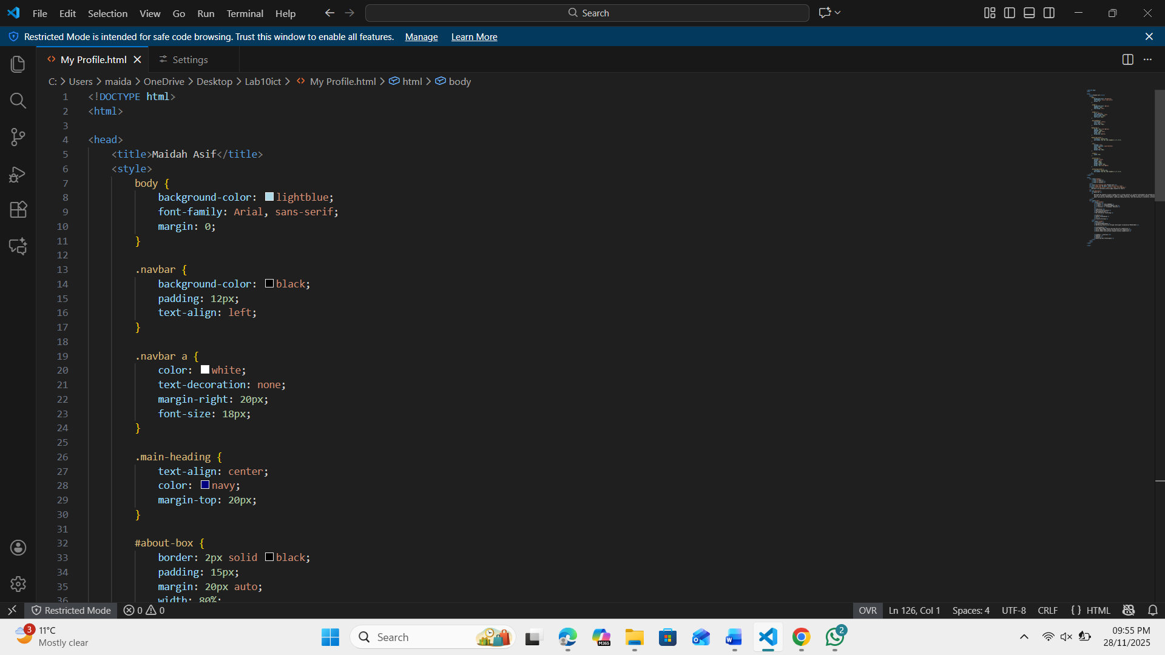

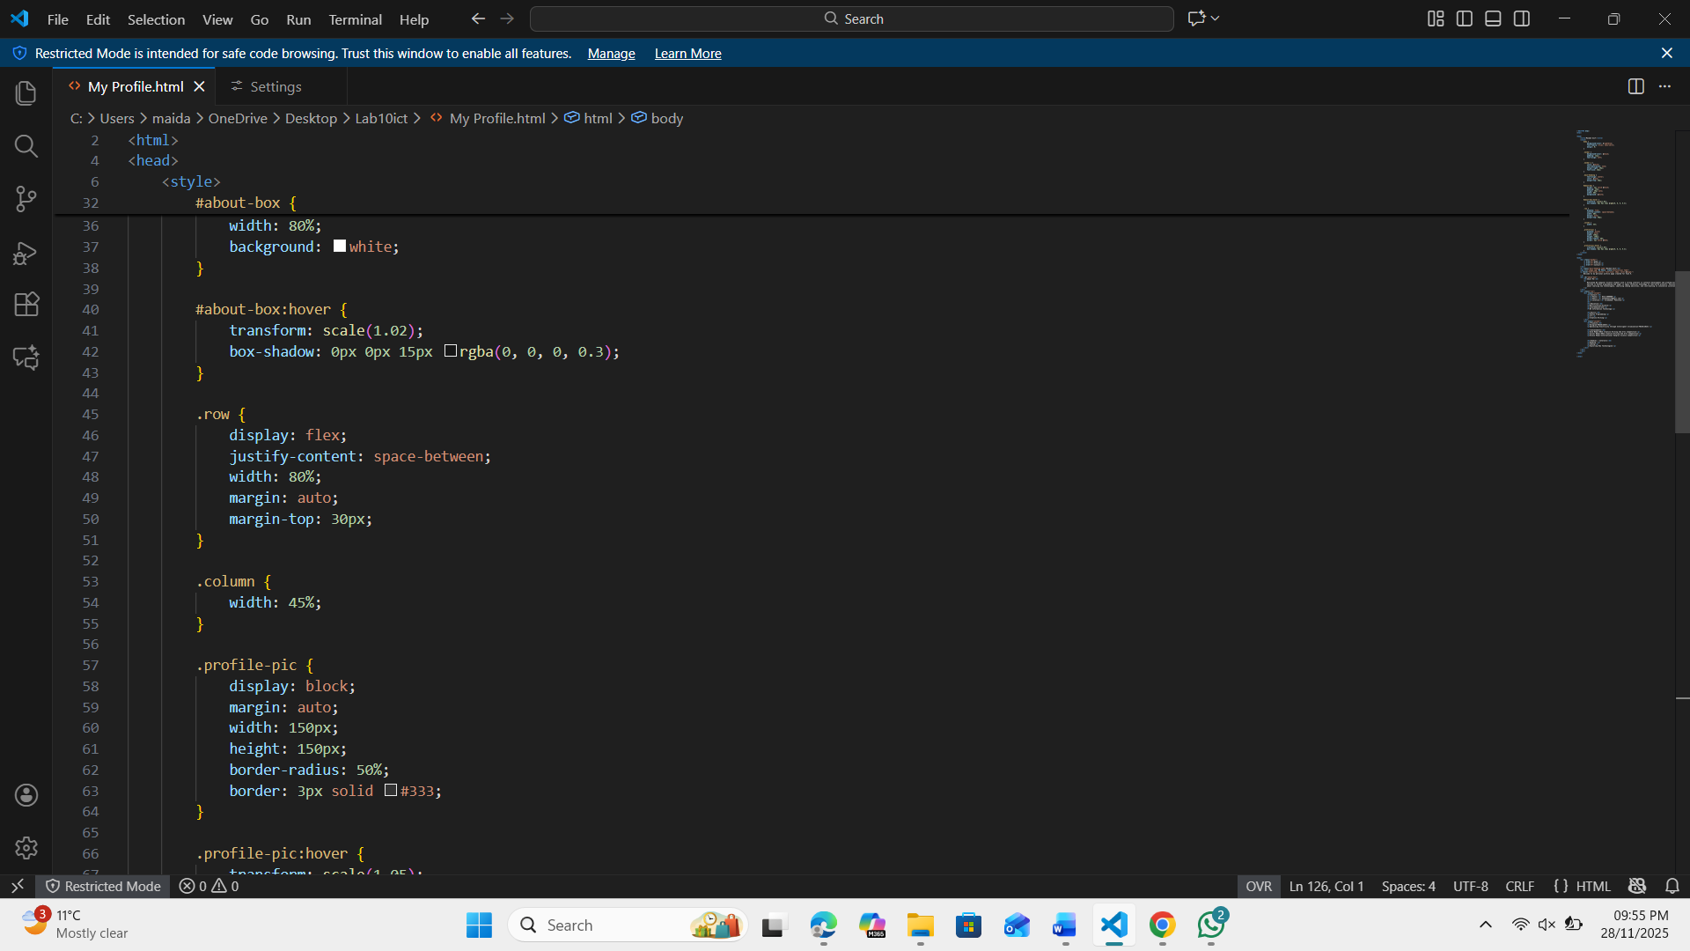
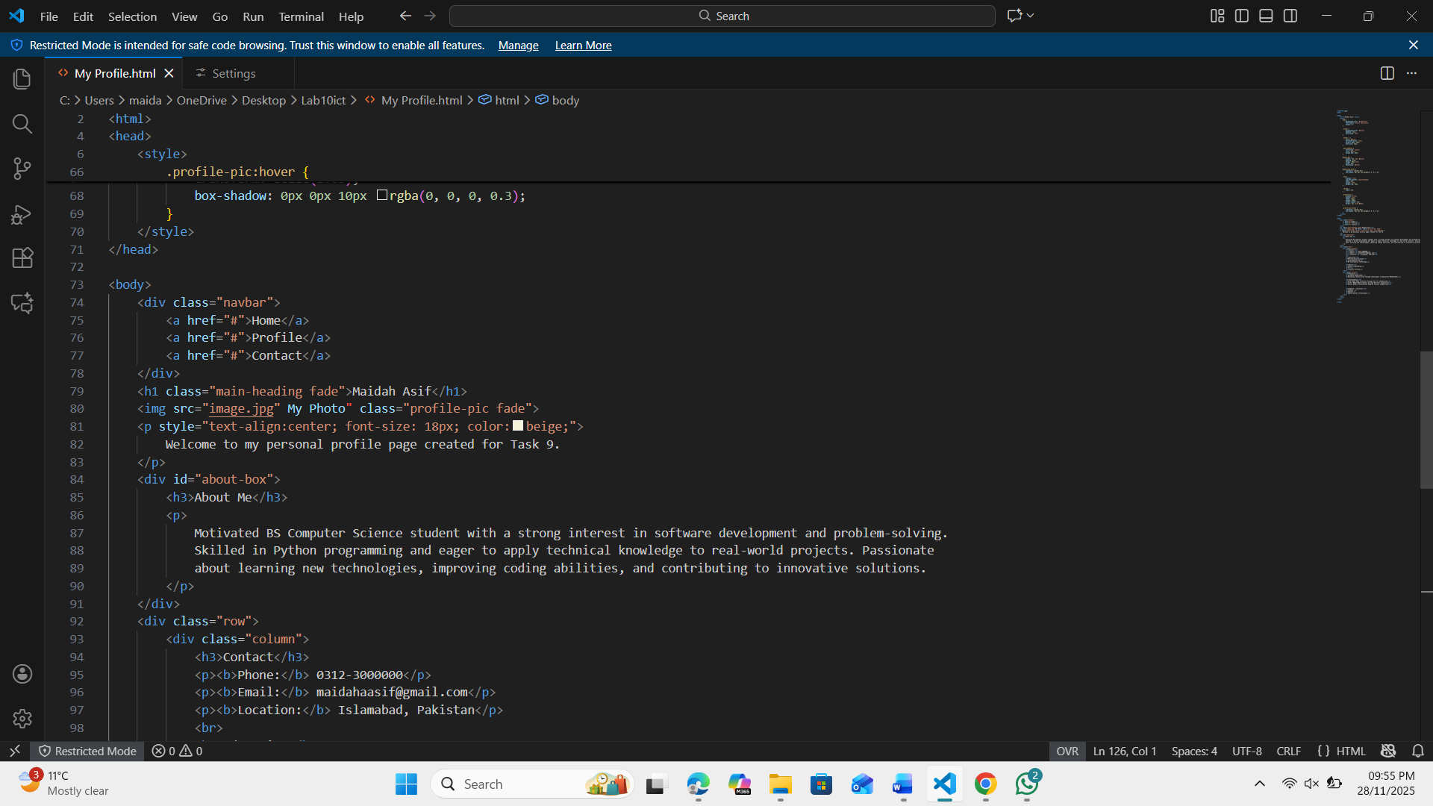
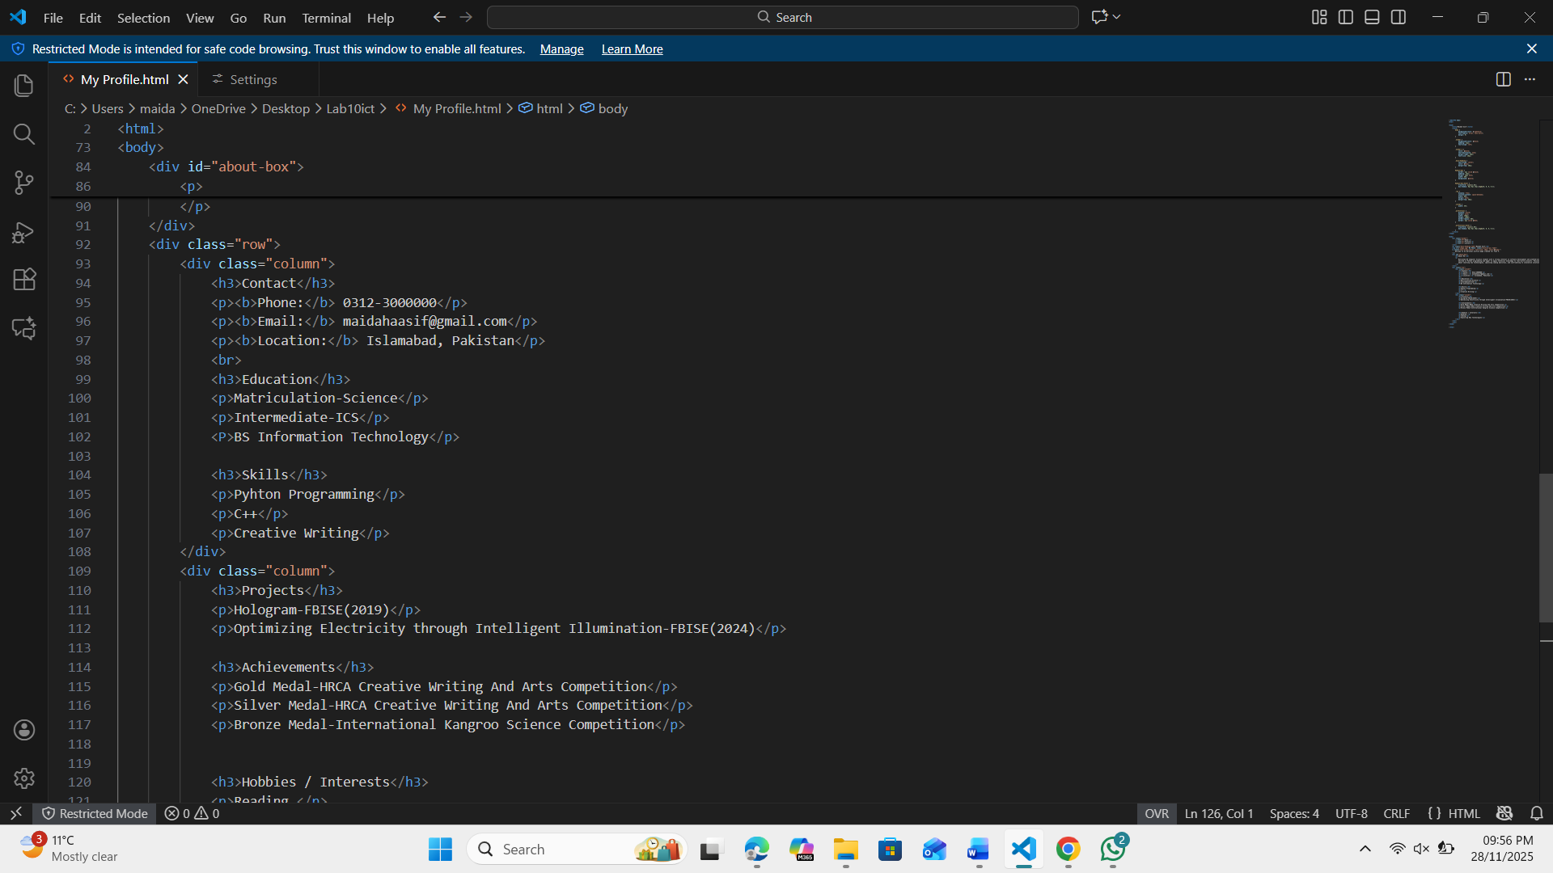
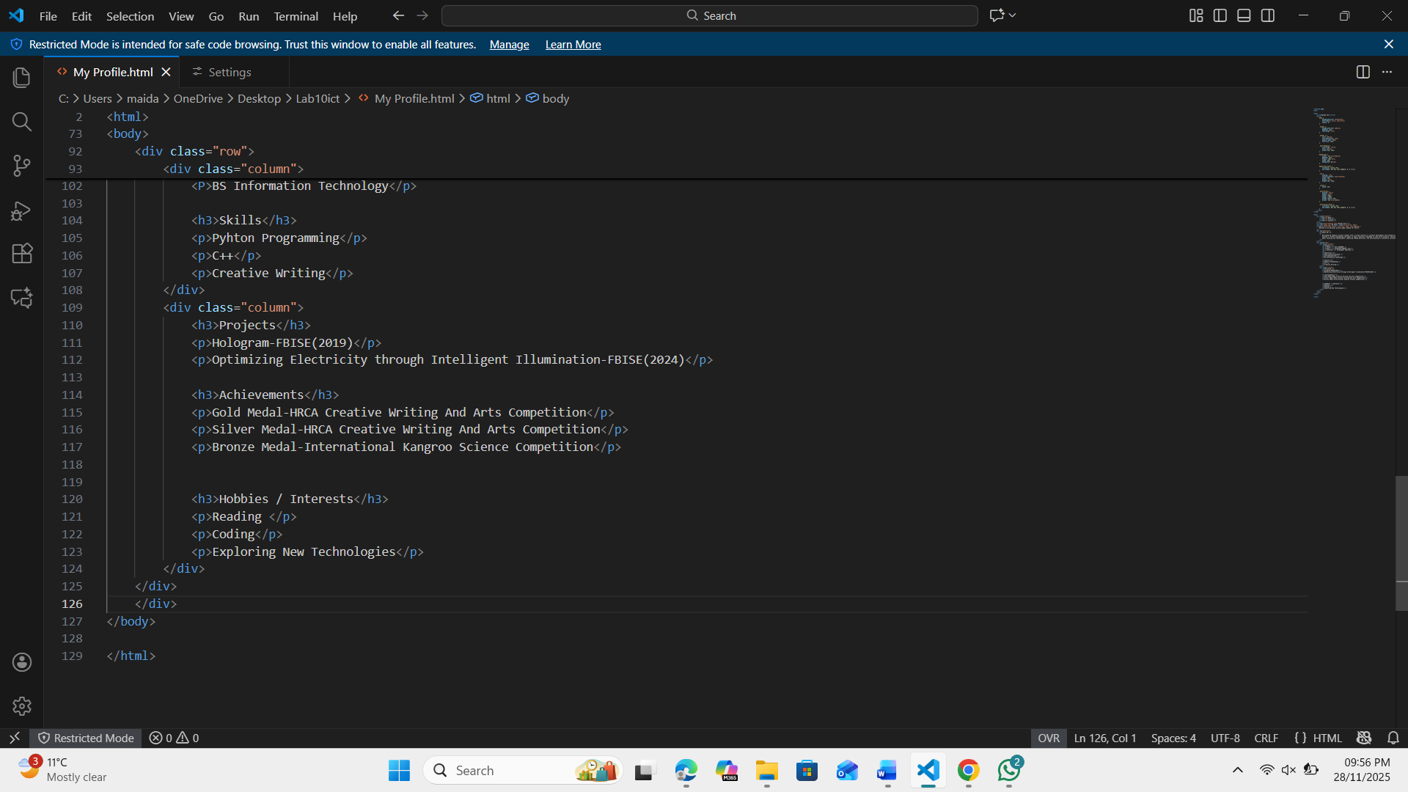

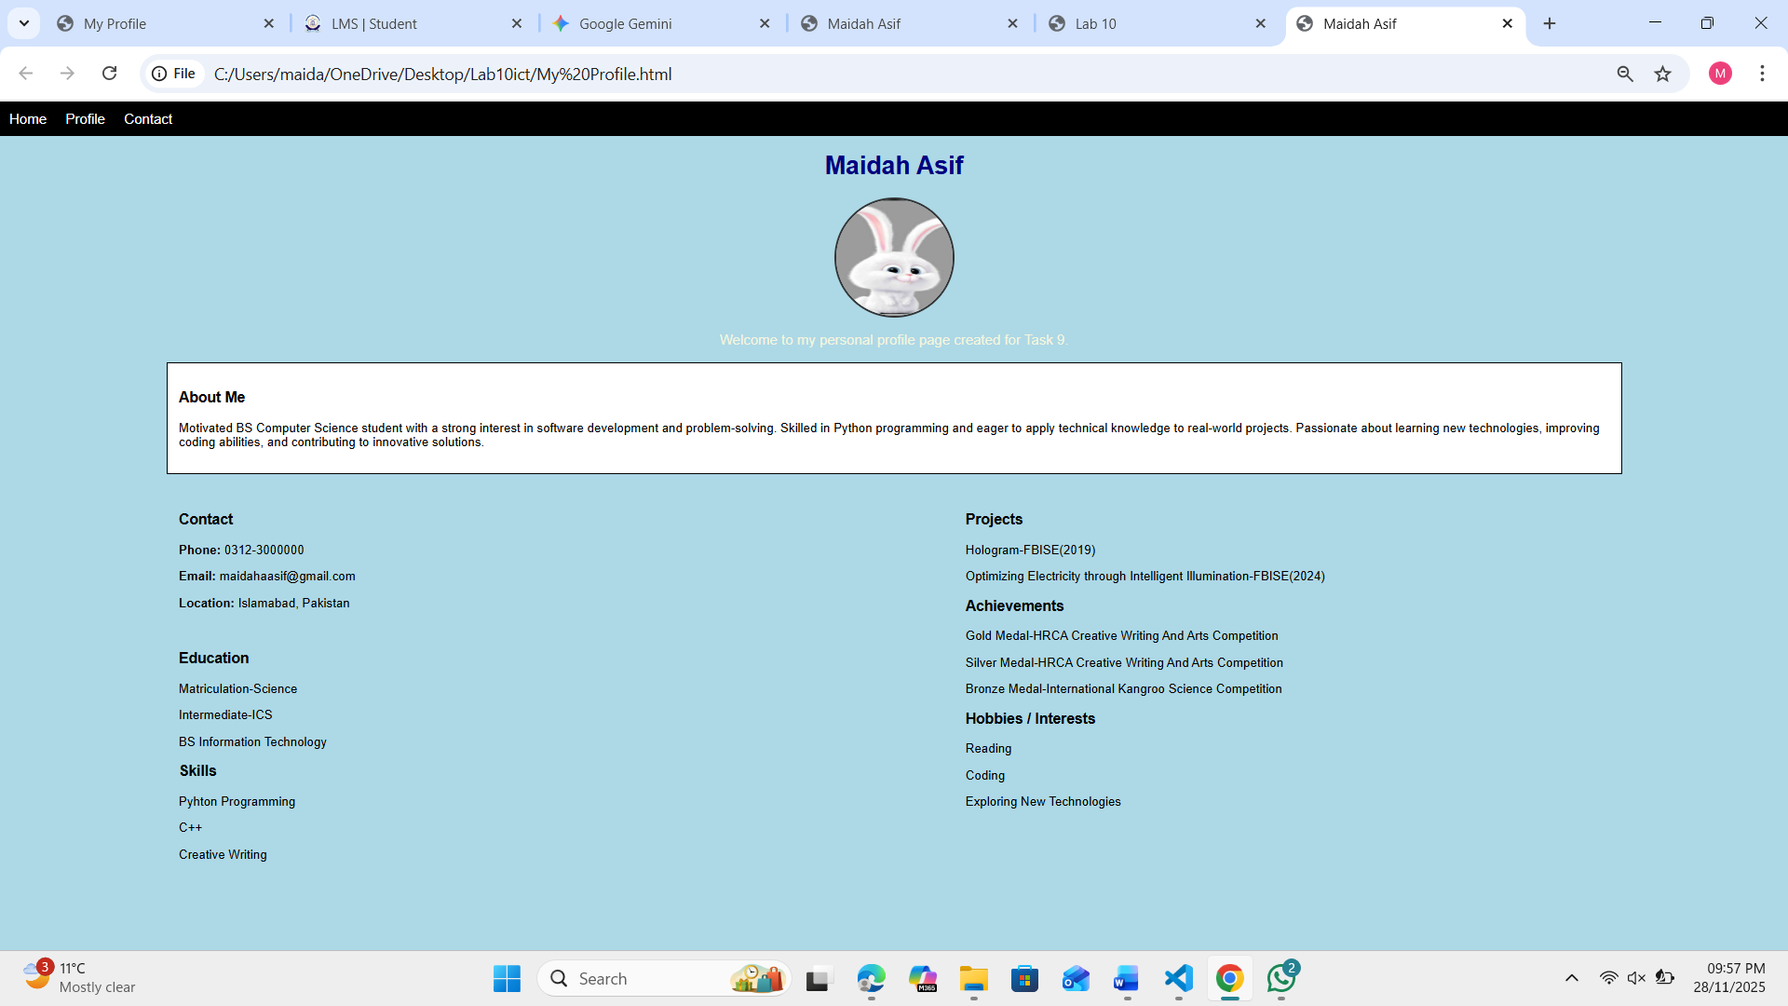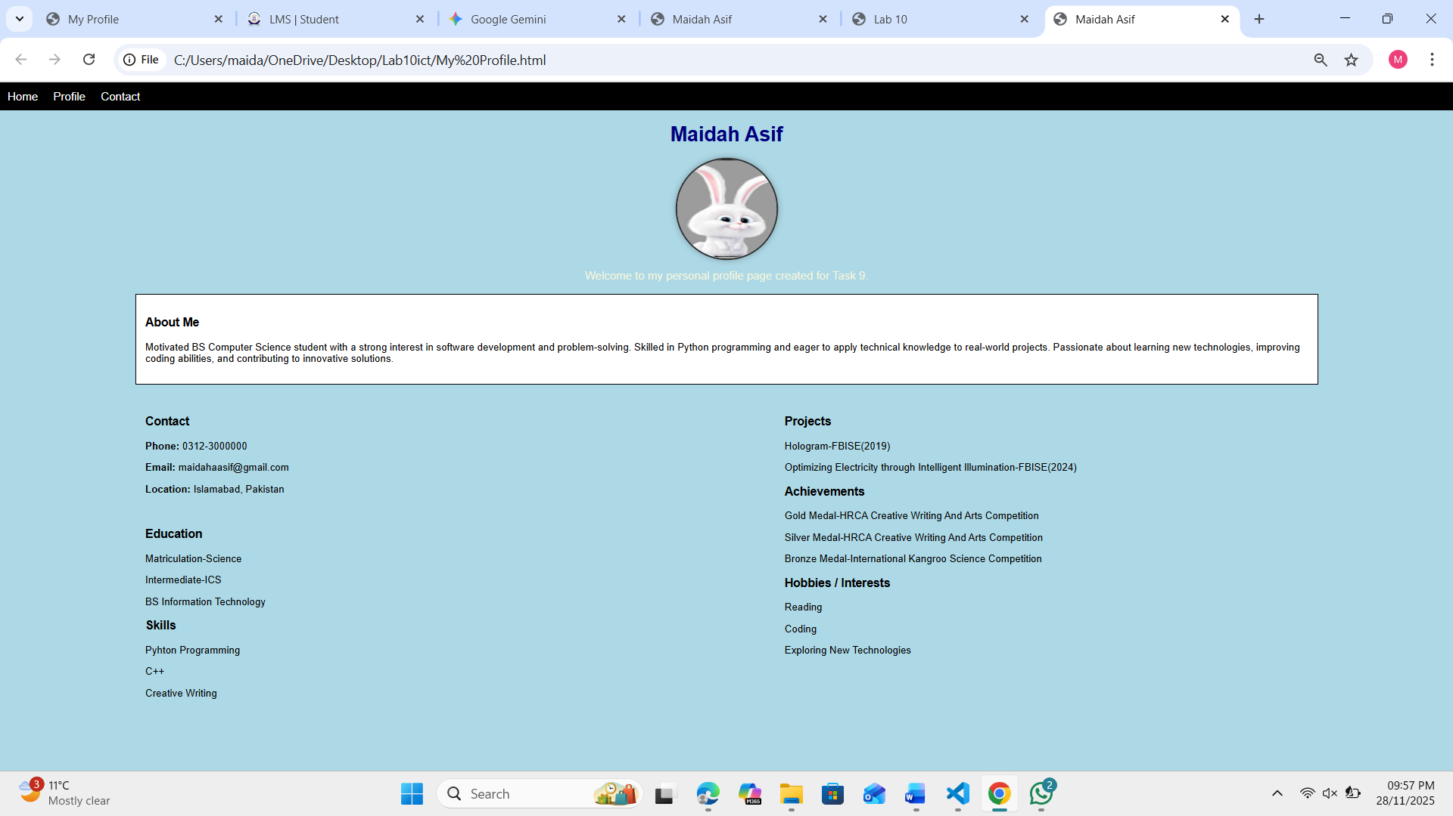

Assessment Questions
  - What is the difference between a class selector (.className) and an ID selector (#idName) in CSS?
.className:can be used for multiple elements
#idName:Must be unique used for only one element

  - Write the internal CSS needed to change all <h1> headings to blue and center them.
(Only CSS required)
h1{
color:blue;
text-align:centre;
}

  - What is the purpose of the required attribute in an HTML form, and why is it useful for user input?
It is useful to prevent empty and incomplete inputs and ensures user cannot submit the form without filling that field

  - Write the HTML + internal CSS to create a square <div> of size 100px × 100px that changes color when hovered.
<style>
.square{
width:100px;
height:100px;
background-color:red;
}
.square:hover{
background-color:blue;
}
</style>
<div class=”square”></div>

  - What is the purpose of the <nav> tag, and why is it used in modern webpages?
The purpose of the <nav> tag is to define the navigation section of a webpage.In modern webpages it helps the users to understand the structure of the page.

